

Analytics in a Day  
Azure Synapse + Power BI better together

Exercise 08

# Publish a Power BI Report

## Overview

The estimated time to complete this exercise is 45 minutes.

Important: You must successfully complete Exercise 07 before commencing this exercise.

In this exercise, you are working in the role of a data analyst.

You will use Power BI Desktop to connect to the Sale Analysis dataset published in Exercise 06. You will then develop a multi-page report, which will include synced slicers, a custom visual, page drill through, a report-level measure, bookmarks, and buttons. You will finalize the exercise by publishing the report to the Power BI service, and then exploring it in the service.

## Section 1: Create a Report

In this section, you will create a live connection report to the Sale Analysis dataset.

### Task 1: Get Started

In this task, you will create a Power BI Desktop solution.

1. Open Power BI Desktop.
2. If the getting started window opens, at the top-right of the window, click X.



1. To save the Power BI Desktop solution, on the File tab (backstage view), select Save.
2. Save the file as Sale Report to an easy-to-remember location in your file system.

### Task 2: Create a Live Connection

In this task, you will create a live connection to the Sale Analysis dataset.

1. On the Home ribbon, from inside the Data group, click Get Data, and then select Power BI Datasets.

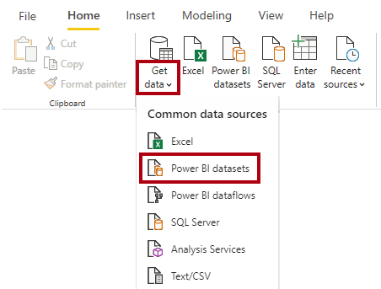

1. In the Select a Dataset window, notice that the Sale Analysis dataset is endorsed as a promoted dataset.
2. Select the Sale Analysis dataset.

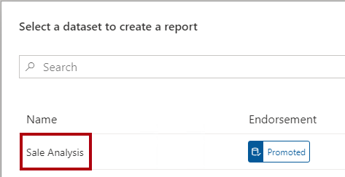

1. Click Create.

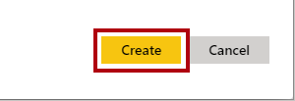

1. In the status bar, at the right, notice the live connection status.



1. Save the Power BI Desktop solution.

## Section 2: Develop the Report Layout

In this section, you will develop a two-page report.

### Task 1: Develop Page 1

In this task, you will develop the first report page.

The completed report page will look like the following:

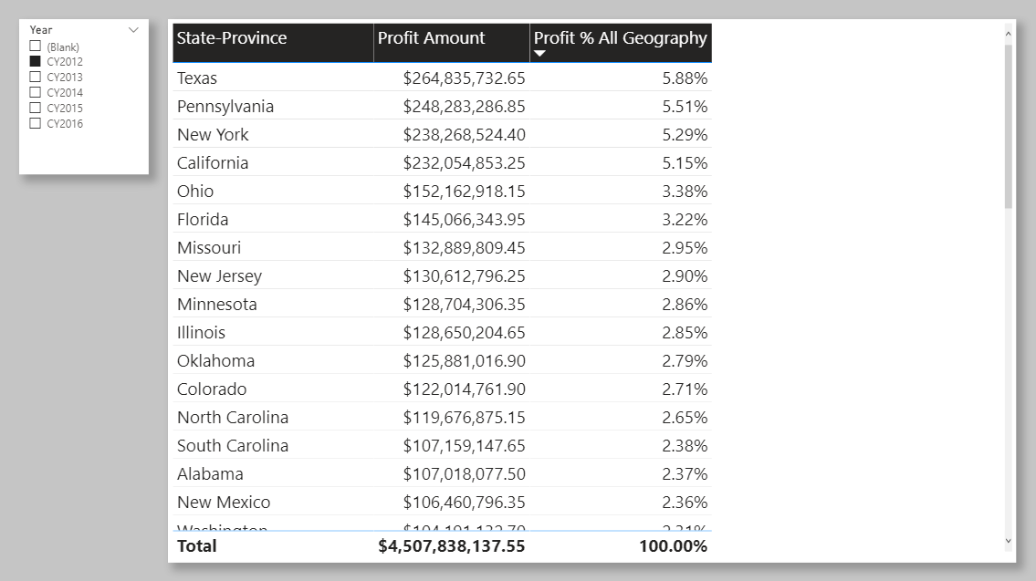

1. To rename the report page, at the bottom-left, double-click Page 1.
2. Replace the text with Profit Analysis, and then press Enter.

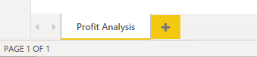

1. To format the page, in the Visualizations pane, select the Format pane (paint roller icon).

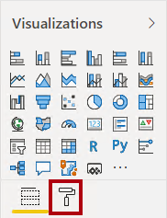

You’ll format many report elements in this exercise to produce a professional report layout. To format an element, you’ll select it, and then access formatting options in this pane. Formatting options are organized into sections.

1. Expand the Page Background section.

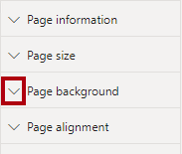

1. Open the Color palette, click Custom Color, and set the custom color C5C5C5.
2. Set the Transparency property to 0%.
3. Add a slicer to the page.

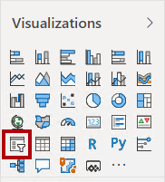

1. Position and size the slicer at the top-left of the report page.



1. In the Fields pane, expand the Date table, and then drag the Year field (not the Year level of the hierarchy) into the slicer.

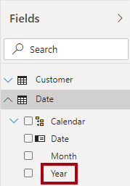

1. Ensure that the slicer is selected, and then open the Format pane.
2. Turn the Shadow property on.

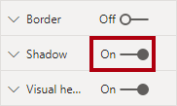

For a consistent style, you’ll be instructed to add shadow to all elements you add to the report.

1. In the slicer, select CY2012.

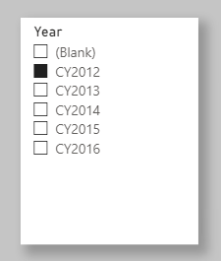

1. To create a new visual, first select an empty area of the report canvas.
2. To add a table visual to the report canvas, in the Visualizations pane, click the table visual icon.

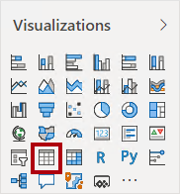

1. Position the table visual at the right of the slicer, and resize it to fill the remaining page space.



1. Add the following fields to the table visual:

* Geography table State-Province field
* Sale table Profit Amount field
* Sale table Profit % All Geography

1. Apply the following table visual formats:

* In the Style section, set the Style to Bold Header.
* In the Grid section, increase the Text Size property to 16 pt.
* Turn Shadow on.

1. To sort the table visual rows, click the Profit % All Geography column header to sort by descending profitability.

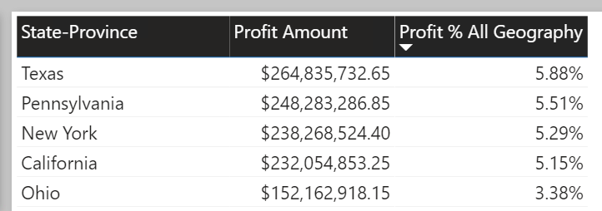

1. Save the Power BI Desktop solution.

### Task 2: Develop Page 2

In this task, you will develop the second report page.

The completed report page will look like the following:

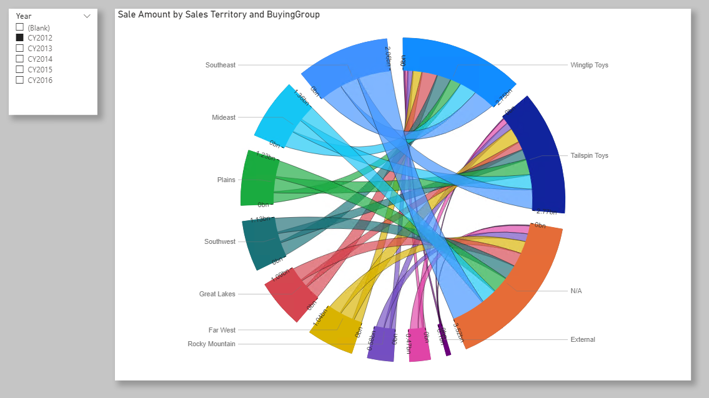

1. To duplicate the report page, at the bottom-left, right-click the Profit Analysis page, and then select Duplicate Page.



Tip: Duplicating the page copies the formatting options. It can be quicker to duplicate than to reapply formats. And, it’s likely to result in more design consistency.

1. Rename the new page as Sale Chord.

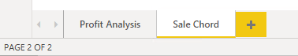

1. To delete the table visual, select the visual, and then press the Delete key.
2. To sync the slicers, on the View ribbon tab, from inside the Show Panes group, select Sync Slicers.

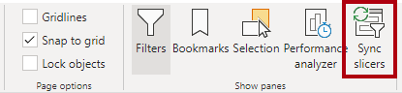

1. In the report page, select the Year slicer.
2. In the Sync Slicers pane (located at the left), check both pages to sync.

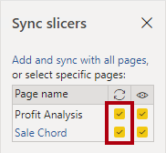

When a report user changes either Year slicer, the filter will propagate between these pages. Both slicers will remain in sync.

1. In the Sync Slicers pane, at the top-left, click X.



1. To import a custom visual, in the Visualizations pane, click the ellipsis (…), and then select Get More Visuals.

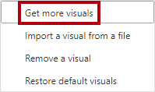

1. In the Power BI Visuals window, in the Search box, enter Chord, and then press Enter.

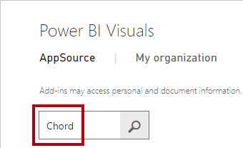

1. When the Chord search result appears, click Add.

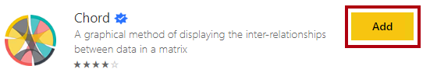

1. When the custom visual imports, click OK.
2. In the Visualizations pane, notice that the chord custom visual sits in an area beneath the core Power BI visuals.

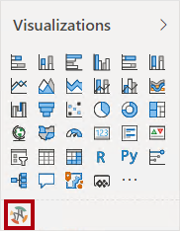

1. Add a chord visual to the report page.
2. Position the chord visual at the right of the slicer, and resize it to fill the remaining page space.



1. Configure the following visual field wells:

* From: Geography table Sales Territory field
* To: Customer table Buying Group field
* Values: Sale table Sale Amount field

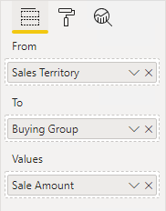

1. Format the chord visual to add shadow.
2. Change the Year slicer values, and notice how the chord visual animates.
3. Hover the cursor over the outer segments and the internal chords to reveal tooltips describing inter-relationships between sales territories and buying groups.
4. Set the Year slicer back to CY2012.
5. Save the Power BI Desktop solution.

## Section 3: Develop a Drill Through Page

In this section, you will develop a drill through page.

### Task 1: Develop a Drill Through Page

In this task, you will develop a drill through page allowing report users to see detail data for a state-province.

The completed report page will look like the following:

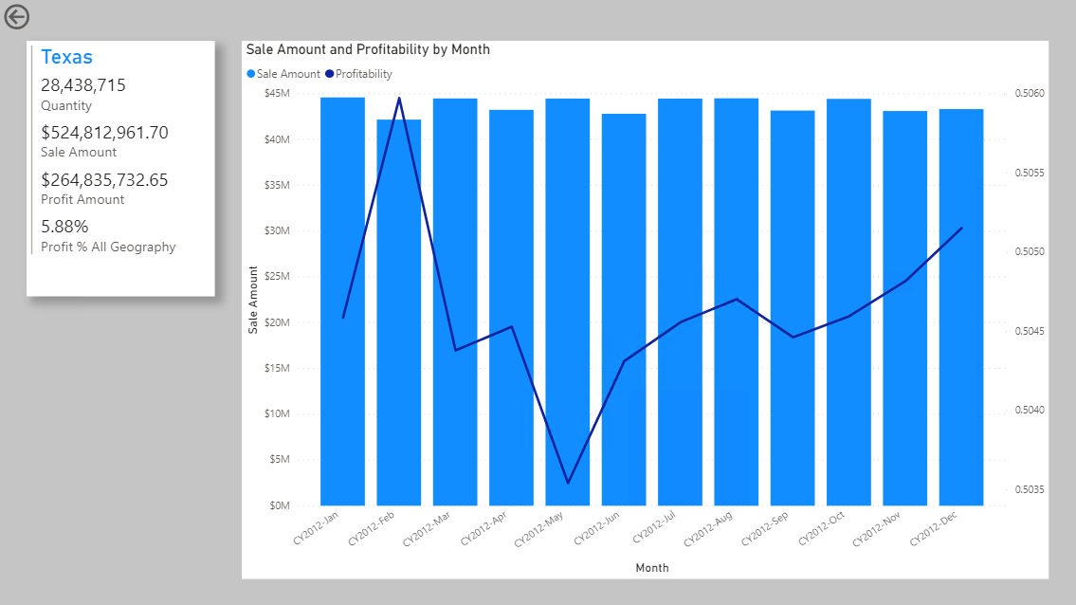

1. Create a new report page by duplicating the Sale Chord page.
2. Rename the new page as State-Province Details.

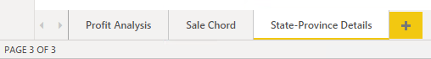

1. Remove the slicer and chord visual.
2. From the Fields pane, in the Geography table, drag the State-Province field to the Drill Through section (beneath the Visualizations pane), into the well.

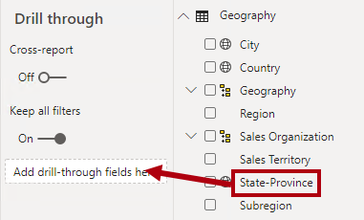

1. Apply a filter to the first state, Alabama.

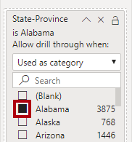

The filter will be applied when the report user drills through. You applied this filter now to help design the page for a single state.

1. At the top-left of the report page, notice the back arrow button.

The button was added automatically when you added a drill through filter. It allows report users to navigate back to where they drilled.

1. Select the button, and the in the Visualizations pane, turn the Background off.

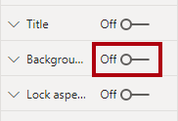

1. Add a multi-row card visual to the report page.

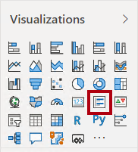

1. Position and size the multi-row card visual at the top-left of the report page.



1. Add the following five fields to the multi-row card visual:

* Geography table State-Province field
* Sale table Quantity field
* Sale table Sale Amount field
* Sale table Profit Amount field
* Sale table Profit % All Geography field

1. Apply the following formats:

* In the Data Labels section, set the Text Size to 16 pt.
* In the Card Title section, set the Text Size property to 20 pt.
* Turn Shadow on.

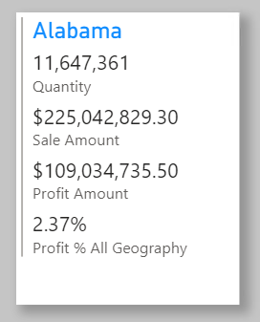

1. Add a line and clustered column chart visual to the report page.

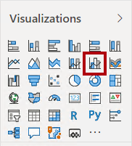

1. Position the line and clustered column visual at the right of the slicer, and resize it to fill the remaining page space.



1. Configure the following field mappings:

* Shared Axis: Date table Month field
* Column Values: Sale table Sale Amount field

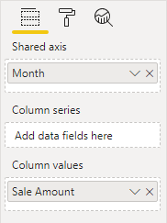

1. To add a report-level measure, in the Fields pane, right-click the Sale table, and then select New Measure.

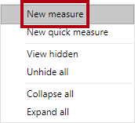

A report-level measure can be added by the report author. It allows them to define new measures that aren’t already defined in the model.

1. In the formula bar, enter the following measure definition:
   1. DAX
   2. Profitability =  
      DIVIDE(  
       SUM(Sale[Profit Amount]),  
       SUM(Sale[Sale Amount])  
      )

The formula divides the sum of the Profit Amount column by the sum of the Sale Amount column.

1. On the Measure Tools contextual ribbon tab, set the format to percentage.

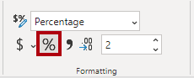

1. Add the Profitability measure to the Line Values well of the line and clustered column visual.

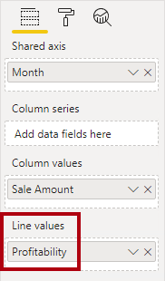

1. Format the line and clustered column visual to add shadow.

The design of the drill through page is now complete.

1. Right-click the State-Province Details page tab, and then select Hide Page.

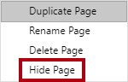

Report users won’t see the page tab, but they’ll be able to drill through to the page. You’ll now test the drill through experience.

### Task 2: Explore Drill Through

In this task, you will explore the drill through experience.

1. Select the Profit Analysis page.
2. Ensure the Year slicer is set to CY2012.
3. In the table visual, right-click any state, and then select Drill Through > State-Province Details.

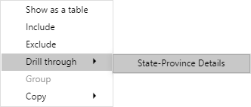

Drill through is available from any report visual that groups by the State-Province field.

1. In the drill through page, notice the state you drilled from is the title of the multi-row card visual.

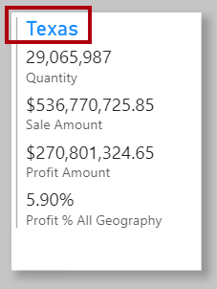

1. Hover the cursor over the top-left corner of the line and clustered column chart visual, and then hover over the filter (funnel) icon.

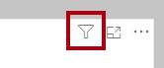

The tooltip reveals all applied filters.

1. Notice that the Year slicer value was passed to the drill through page, too.
2. To return back to where you drilled from, at the top-left corner, while pressing the Ctrl key, click the back button.

When editing a report, you must press the Ctrl key when clicking buttons. If you don’t press the Ctrl key, the designer understands you’re selecting it so it can be configured.

1. Save the Power BI Desktop solution.

## Section 4: Work with Bookmarks

In this section, you will superimpose visuals on the drill through page. You’ll then create bookmarks and assign them to buttons. This design will allow the report user to determine which visual to display.

### Task 1: Create a New Visual

In this task, you will add a new visual to the drill through page.

1. Select the State-Province Details page.
2. Select the line and clustered column chart visual.
3. To clone the visual, press Ctrl+C, and then press Ctrl+V.
4. Position the cloned visual precisely over the top of the original visual.
5. Modify the top visual field Shared Axis field mappings by removing the Month field, and then replacing it with the Salesperson table Salesperson field.

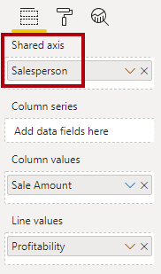

1. Format the visual data color by setting the Default Color to purple.

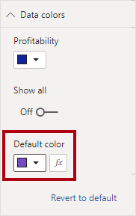

### Task 2: Create Bookmarks

In this task, you will create two bookmarks to show or hide the superimposed visuals.

1. On the View ribbon tab, from inside the Show Panes group, select Bookmarks and Selection.

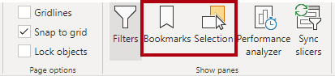

1. In the Selection pane, notice there are two similarly named report elements.

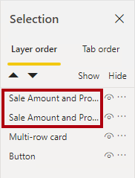

1. Hover the cursor over each to reveal a tooltip describing their full title.
2. Notice that one ends in “by Month”, and the other ends in “by Salesperson”.
3. Determine which of the visuals groups by salesperson, and then click the Hide icon.

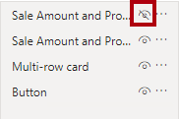

1. Verify that the “by Month” visual is now visible.
2. In the Bookmarks pane, click Add.

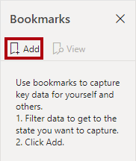

1. To rename the bookmark, double-click Bookmark 1.
2. Rename the bookmark as By Month, and then press Enter.
3. Click the ellipsis at the right of the bookmark, and then select Data.

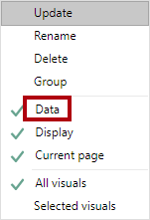

By selecting Data, you’re disabling the bookmark from capturing any applied filters. It means that when the bookmark is applied, it’ll use the filters applied by the report user.

1. Click the ellipsis again, and then select Update.

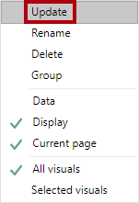

1. In the Selection pane, unhide the visual, and then hide the visual that groups by month.
2. Create a second bookmark, and then name it By Salesperson.
3. Configure the bookmark to not override filters (turn off Data), and then update the bookmark.
4. Verify there are two bookmarks.

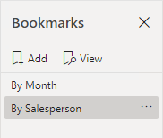

1. Close the Selection pane.



1. Close the Bookmarks pane.



### Task 3: Add Buttons

In this task, you will add two buttons to the report page, and then configure each to select a bookmark.

1. On the Insert ribbon tab, from inside the Elements group, click Buttons, and then select Blank.

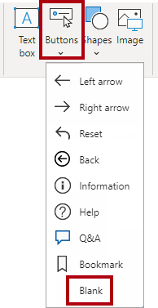

1. Position and size the button as follows:
2. Position and size the button so that it is directly beneath the multi-row card visual and it is the same width.



1. In the Visualizations pane, apply the following button formats:

* Set the Button Text section to On.
* Expand the Button Text section, and then set the Button Text to By Month.
* Set the button text Font Color to Black.
* Set the button text Text Size to 16 pt.
* Set the Fill section to On.
* Set the fill Fill Color to Blue.
* Set the Shadow section to On.
* Set the Action section to On.
* Set the action Type to Bookmark.
* Set the action Bookmark to By Month.

1. Clone the button, and then position it directly beneath the first button.

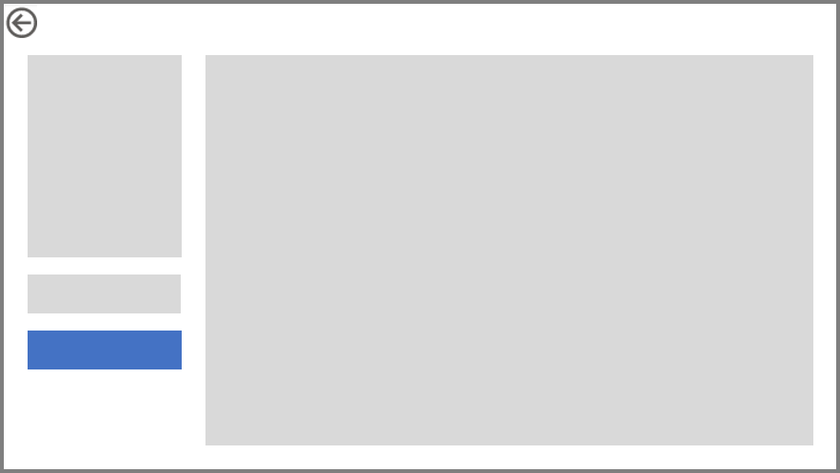

1. Modify the button formats, as follows:

* Set the Button Text to By Salesperson.
* Set the fill Fill Color to Purple.
* Set the action Bookmark to By Salesperson.

1. Verify that the buttons looks like the following:

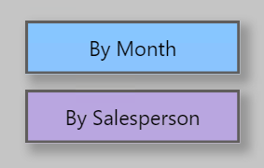

1. Test each button by pressing the Ctrl key and clicking a button.

## Section 5: Publish the Report

In this section, you will prepare the report for publication, and then publish it to Power BI.

### Task 1: Prepare the Report

In this task, you will prepare the report for publication.

1. On the State-Province Details page, ensure the By Month visual is displayed.
2. Select the Profit Analysis page.
3. Ensure the Year slicer is set to CY2012.

It’s important to select the initial page and reset filters just before publishing the report. It will become the report state when report users first open the report.

1. Save the Power BI Desktop solution.

### Task 2: Publish the Report

In this task, you will publish the report to Power BI.

1. On the Home ribbon tab, from inside the Share group, click Publish.

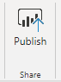

1. If prompted to save changes, click Yes.
2. In the Publish to Power BI window, select the lab workspace (do not use My Workspace).
3. Click Select.

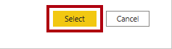

1. When publication has completed, click Got It.
2. Close Power BI Desktop.

### Task 3: Explore the Report

In this task, you will explore the report to determine root cause for low-profit earning state.

1. Switch to the Power BI web session.
2. Switch to the workspace where you published the report.
3. Open the Sale Report.
4. At the left, notice there are only two pages.

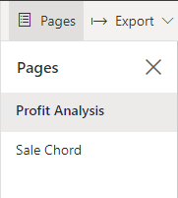

The drill through page was hidden.

1. Set the Year slicer to CY2014.
2. Understand that the page refreshed quickly because Power BI is querying the aggregation.
3. To see low-profit states, modify the table sort to Profit % All Geography ascending.
4. To understand Hawaii sales in more detail, right-click Hawaii, and then drill through to the details page.
5. Review the monthly sales.
6. Click the By Salesperson button, and then review the result by salespeople.

## Summary

In this exercise, you used Power BI Desktop to connect to the Sale Analysis dataset published in Exercise 06. You then developed a multi-page report, which included synced slicers, a custom visual, page drill through, a report-level measure, bookmarks, and buttons. You then finalized the exercise by publishing the report to the Power BI service, and exploring it in the service.

## Terms of Use

© 2020 Microsoft. All rights reserved.

By using this hands-on lab, you agree to the following terms:

The technology/functionality described in this hands-on lab is provided by Microsoft Corporation in a “sandbox” testing environment for purposes of obtaining your feedback and to provide you with a learning experience. You may only use the hands-on lab to evaluate such technology features and functionality and provide feedback to Microsoft. You may not use it for any other purpose. Without written permission, you may not modify, copy, distribute, transmit, display, perform, reproduce, publish, license, create derivative works from, transfer, or sell this hands-on lab or any portion thereof.

COPYING OR REPRODUCTION OF THE HANDS-ON LAB (OR ANY PORTION OF IT) TO ANY OTHER SERVER OR LOCATION FOR FURTHER REPRODUCTION OR REDISTRIBUTION WITHOUT WRITTEN PERMISSION IS EXPRESSLY PROHIBITED.

THIS HANDS-ON LAB PROVIDES CERTAIN SOFTWARE TECHNOLOGY/PRODUCT FEATURES AND FUNCTIONALITY, INCLUDING POTENTIAL NEW FEATURES AND CONCEPTS, IN A SIMULATED ENVIRONMENT WITHOUT COMPLEX SET-UP OR INSTALLATION FOR THE PURPOSE DESCRIBED ABOVE. THE TECHNOLOGY/CONCEPTS REPRESENTED IN THIS HANDS-ON LAB MAY NOT REPRESENT FULL FEATURE FUNCTIONALITY AND MAY NOT WORK THE WAY A FINAL VERSION MAY WORK. WE ALSO MAY NOT RELEASE A FINAL VERSION OF SUCH FEATURES OR CONCEPTS. YOUR EXPERIENCE WITH USING SUCH FEATURES AND FUNCITONALITY IN A PHYSICAL ENVIRONMENT MAY ALSO BE DIFFERENT.

FEEDBACK If you give feedback about the technology features, functionality and/or concepts described in this hands-on lab to Microsoft, you give to Microsoft, without charge, the right to use, share and commercialize your feedback in any way and for any purpose. You also give to third parties, without charge, any patent rights needed for their products, technologies and services to use or interface with any specific parts of a Microsoft software or service that includes the feedback. You will not give feedback that is subject to a license that requires Microsoft to license its software or documentation to third parties because we include your feedback in them. These rights survive this agreement.

MICROSOFT CORPORATION HEREBY DISCLAIMS ALL WARRANTIES AND CONDITIONS WITH REGARD TO THE HANDS-ON LAB, INCLUDING ALL WARRANTIES AND CONDITIONS OF MERCHANTABILITY, WHETHER EXPRESS, IMPLIED OR STATUTORY, FITNESS FOR A PARTICULAR PURPOSE, TITLE AND NON-INFRINGEMENT. MICROSOFT DOES NOT MAKE ANY ASSURANCES OR REPRESENTATIONS WITH REGARD TO THE ACCURACY OF THE RESULTS, OUTPUT THAT DERIVES FROM USE OF THE VIRTUAL LAB, OR SUITABILITY OF THE INFORMATION CONTAINED IN THE VIRTUAL LAB FOR ANY PURPOSE.

DISCLAIMER This lab contains only a portion of new features and enhancements in Microsoft Power BI. Some of the features might change in future releases of the product.